NOVICE TEST

1. Castling

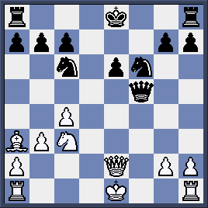

- White can castle Kingside.
- White can castle Queenside.
- White can castle both sides.
- White cannot castle any side.
- Black can castle Kingside.
- Black can castle Queenside.
- Black can castle both side.
- Black cannot castle any side.

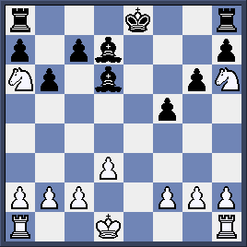

a) White can castle Kingside.
b) White can castle Queenside.
c) White can castle both sides.
d) White cannot castle any side.
e) Black can castle Kingside.
f) Black can castle Queenside.
g) Black can castle both side.
h) Black cannot castle any side.

a) White can castle Kingside.
b) White can castle Queenside.
c) White can castle both sides.
d) White cannot castle any side.
e) Black can castle Kingside.
f) Black can castle Queenside.
g) Black can castle both side.
h) Black cannot castle any side.

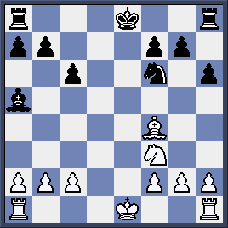

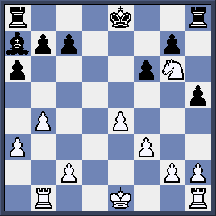

a) White can castle Kingside.
b) White can castle Queenside.
c) White can castle both sides.
d) White cannot castle any side.
e) Black can castle Kingside.
f) Black can castle Queenside.
g) Black can castle both side.
h) Black cannot castle any side.

2. Check – Double Check – Checkmate:
Write down possible moves for White in the following position.
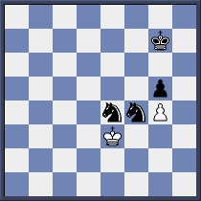
1………………………
2………………………
3………………………

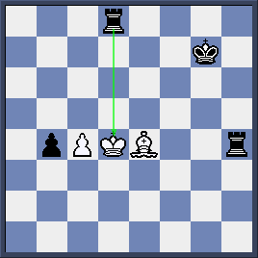
White King is checked. Please write down 3 moves which help White to get out of check.

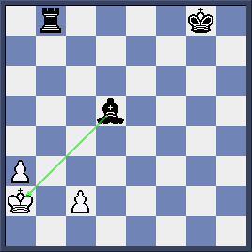
White has 2 moves to get out of check. Please write down these moves.

2. ………….....
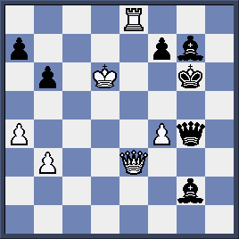
White has 2 moves to get out of check.
Please write down these moves.
1. …………….

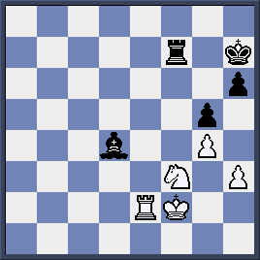
White King is checked by Black Bishop. Can White capture it to get out of check?
➢Yes
➢No

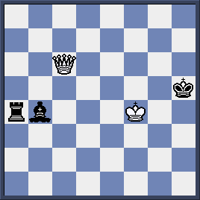
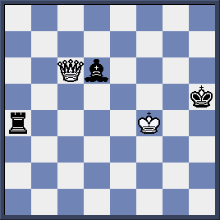

Black has just moved Bd4-d6+. Can White Queen either take Black Rook or Bishop?
➢Yes
➢No

